Exam 2 – Fall 2019
BCH 341 - Physical Chemistry with a Biological Focus
Professor Jeff Yarger

September 21-23, 2019

DUE Monday September 23, 2019 by 11:59 PM (UTC-7). Turn in completed exam as a typeset single PDF document into the assignment link on ASU Canvas. Please make sure the completed exam is organized, self-contained and all text, equations, numbers, units, figures and images are typeset, clear and legible.

Student Required Identification:

Last 4-Digits of my ASU ID #:_________________
(typically starting with 12xxxxxxxx or 10xxxxxxxx)

Student OPTIONAL Identification:

Email: ______________________________________
(email address that does not provide obvious personal identification)

Exam General Instructions
To aid in the optional anonymous peer review process (after the due date for this exam, Sept 24-26), you do NOT need to include your full name, just the last 4 digits of your ASU student ID. There is the option of including an email address for contact purposes (which is really helpful). It is recommended that you use an email address that does not contain any obvious personal information (e.g., first or last name).

There are 5 multi-component exercises/projects on this exam. Pick 4 of the 5 problems to complete. Each of the multi-component numbered exercises/projects (problems) is worth 25 points. Hence, the exam is worth a total of 100 points. If you do not include a number in the space below and provide answers for all 5 questions on the exam, then the first 4 will be graded. You are required to explicitly show all equations, numerical calculations and associated units. All points are associated with explicitly showing all your work and no points are awarded for just determining the correct numerical answer. All assumptions need to be clearly and concisely stated. If thermodynamic parameters are used, the citation, reference or link to where this thermodynamics data came from must be stated. Appropriate units should be associated with all numerical problem solving. The completed exam should be typeset (no handwriting of equations or numerical values and associated units).

Problem number student omitted (not graded): _____ (1, 2, 3, 4 or 5)

Evaluation Section (filled in my peer reviewers and instructors)
Peer-Review Information
This is a new feature and a trial in ASU Canvas as an additional option for an ‘assignment’ (exam 2 in Canvas). Details about the peer review process will be provided immediately after the due date for this exam.

Summary Peer Review Comment:
___________________________________________________________________________________________
___________________________________________________________________________________________
___________________________________________________________________________________________
___________________________________________________________________________________________

Instructor Grading Summary:
Exam Score: ________ / 100 pts Peer Review Score: ________ / 15 pts

Instructor Comment:
___________________________________________________________________________________________
___________________________________________________________________________________________
1. This exercise will explore the use of temperature-composition (T-χ) diagrams in the study of biological (lipid) systems.

(A) In numerous experimental study of model membrane-like assembly, a T-χ phase diagram of dielaidoylphosphatidylcholine (DEL) and dipalmitoylphosphatidylcholine (DPL) is often used as an example ‘ideal’ miscible binary system. A schematic T-χ phase diagram is reproduced from Atkins as Fig. 1 below. Explain what happens as a liquid mixture of composition χ_{DEL}=0.5 is cooled from 45ºC to 0ºC. (5 pts)

(B) One of the best ways to better understand a topic is to go back to the experimental (or computational) studies and its associated data analysis and interpretation. The experimental T-χ phase diagram for DEL:DPL was first published by C. Grant et. al., Biochimica et Biophysica Acta, 363 (1974) 151-158. Figure 2 from this publication is reproduced below (as Fig. 2). Explain what happens as a fluid (‘liquid’) mixture of composition χ_{DEL}=0.5 is cooled from 45ºC to 0ºC. (5 pts)
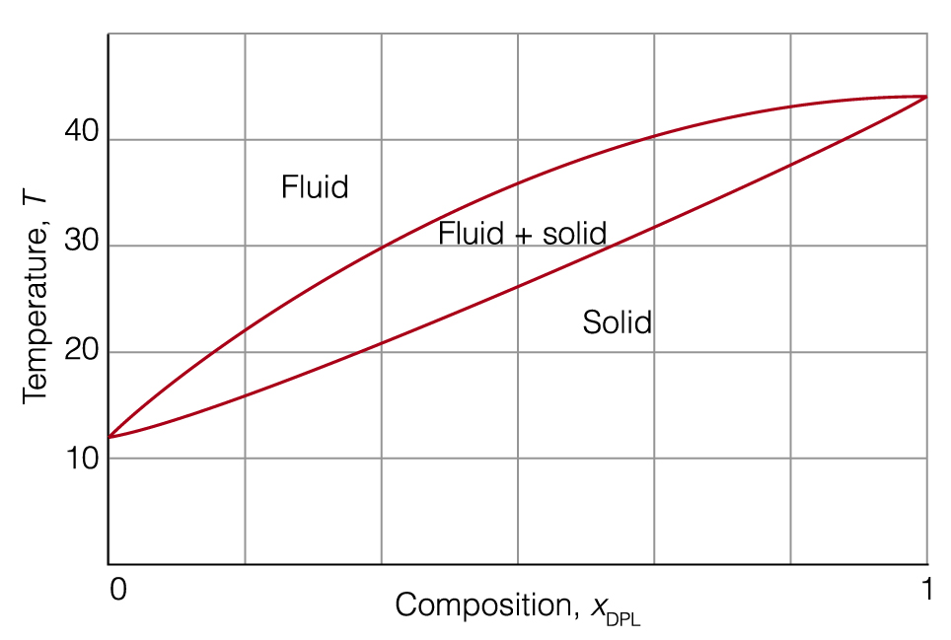
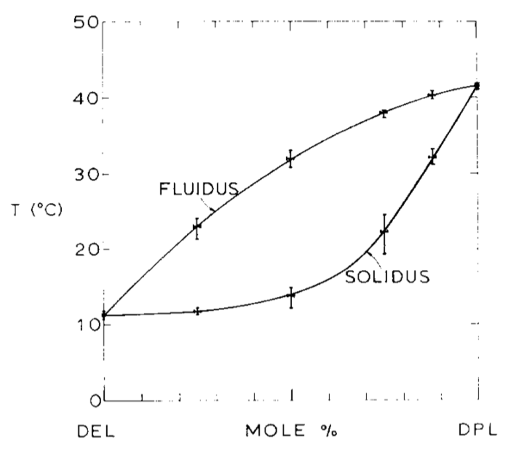

Fig. 1 – Schematic phase diagram (Atkins, 3.40) Fig. 2. Experimental phase diagram (Grant, et. al.)

(C) This binary lipid system (DEL:DPL) has been extensively studied and is one of several that commonly gets used as model system for understanding lipid phase transitions and phase diagrams. There are many thermodynamic values and physical properties that can be determined directly or indirectly from phase diagrams. Its really useful to try and estimate (or calculate) as many different thermodynamic parameters of DEL and DPL as possible using the above experimental phase diagram (Fig. 2). However, to be specific for exam purposes, estimate (or calculate) the change in enthalpy (ΔH, latent heat of ‘melting’ or ‘fusion’) expected for this phase transition (for both components). This is one of the most useful and molecularly insightful thermodynamic energies you can determine from a standard T-χ binary phase diagram. Also, report your estimate of the phase transition temperature for each component (lipid). (15 pts)

2. A thermodynamic treatment allows predictions of the stability of DNA. Thermodynamic parameters for calculating double-strand stability typically provide the standard Gibbs free energies (ΔG), enthalpies (ΔH) and entropies (ΔS) of formation at 310 K of short sequences of base pairs as two polynucleotide chains come together. These thermodynamic parameters vary significantly with pH, ionic strength and other common solution conditions. An example of a table of thermodynamic parameters for calculating double-strand stability is provided in the thermodynamic data and tables link at biopchem.education. To estimate the standard Gibbs free energy of formation of a double-stranded piece of DNA, Δ_{DNA}G^{ө}, we sum the contributions from the formation of the sequences and add to that quantity the standard Gibbs free energy of initiation of the process.

Δ_{DNA}G^{ө} = Δ_{init}G^{ө} + Δ_{seq}G^{ө}(sequences)

Similar procedures lead to Δ_{DNA}H^{ө} and Δ_{DNA}S^{ө}.
(A) Provide a molecular explanation for the fact that Δ_{init}G^{ө} is most commonly found to be positive and Δ_{seq}G^{ө} values are always found to be negative. (5 pts)
(B) Estimate the Gibbs free energy, enthalpy and entropy changes as well as the ‘melting’ temperature for the following reaction:

5´-A-G-C-T-G-3´ + 5´-C-A-G-C-T-3´ → $\begin{aligned}5´−A−G−C−T−G−3´ \\ 3´−T−C−G−A−C−5´\end{aligned}$

and please cite the source of any standard thermodynamic parameters. (5 pts)
(C) Estimate the equilibrium constant for the above reaction. (5 pts)
(D) Add one additional nucleotide at any position in both single-strand 5 nucleic acid molecules used in the reaction above (left side), with the goal of making the resultant DNA complex (right side) have the highest possible stability. Show the resulting DNA complex formed from the new 6 nucleotide molecules and thermodynamically determine the additional stability. (10 pts)

3. Show graphically the variation with pH of the composition of a 1.0 millimolar (1.0 mM) aqueous alanine (5 pts) and a 1.0 millimolar (1.0 mM) aqueous glutamic acid (10 pts) solution. Try to minimize assumptions and calculate all concentrations as accurately as possible (5 pts). Show all your work and state any assumptions (5 pts).

4. (A) Use the Boltzmann distribution to describe the molecular features that determine the magnitude of equilibrium constants and their variation with temperature (10 pts). (B) Provide a detailed molecular equilibrium example that helps illustrate your explanation. Include a graphical, visual or animated component in your example. Your example can’t be the same or similar to examples, brief illustrations or case studies shown in Atkin’s textbook, chapter 4. (15 pts)

5. Find a paper in the scientific literature that expands on one of the above exercises/projects (5 pts). Use the additional experimental, computational or theoretical thermodynamic information to further expand upon the thermodynamic concepts in one of the problems above (15 pts). Please provide a proper scientific citation and link for the chosen journal article. (5 pts)

Useful Information – Problem 1
The two lipids are often abbreviated differently from above (and your textbook); dielaidoylphosphatidylcholine (DEPC) and dipalmitoylphosphatidylcholine (DPPC). The DEPC:DPPC (i.e., DEL:DPL) system has been well studied and is often used as a model binary system that displays complete miscibility in the solid state (or sometimes called the gel state). It is easy to calculate and plot a T-χ binary phase diagram similar to Fig. 1. Then you can vary the latent heat of melting to graphically see its effect on the shape and structure of a T-χ binary phase diagram. As is obvious by looking at Fig 1 and 2 side-by-side, the schematic phase diagram is significantly different from the experimental phase diagram.

Useful Information – Problem 5
Examples of topics to search (google scholar, web of science) to help students make the first steps toward picking and exploring ways to extend problems and concepts on the exam, and please be creative and follow your own interests.
For example, in problem 1, a binary system with complete miscibility in the liquid and solid phases is shown. You could find a paper that adds a third component like cholesterol (which makes this model system more interesting from a human health perspective) to introduce ternary phase diagrams and more complex non-ideal lipid thermodynamics.
Another example, would be to find an experimental or computational study of the equilibrium constant in a molecular system where the Boltzmann distribution of energy levels is explicitly determined or discussed. Hence, extending information and examples for problem 4.
All of the above problems represent starting points for advanced biophysical chemistry and molecular thermodynamic topics. Therefore, it should be easy to find scientific journal articles that expands a little (or a lot) on all of the biochemical systems and/or thermodynamic concepts in each of the above problems.

Extra Credit: After your exam is turned in, it will be put into an anonymous peer review system (in Canvas) and students will have 1-2 days to peer review three randomly assigned exams. Students who provide insightful comments will receive 15 extra credit points (5 pts/exam). These points will only be given to students that provide detailed corrections and comments on each of the 3 assigned exams and for each problem within the submitted exam. I think it is possible to leave comments directly in the Canvas LMS. However, it is recommended that the peer reviewer directly comment on the students pdf exam document.

